Name: Jay Rajesh Umap

Roll No.: 2205010

Enrollment No.: MITU20BTIT0029

Class: LY IT Core

Assignment No. 5: Solidity (Part 1)

Execute the following code in remix ide (<https://remix.ethereum.org/>)

// SPDX-License-Identifier: GPL-3.0

pragma solidity >= 0.6.0 < 0.9.0;

/**

    * @title Storage

    * @dev Store & retrieve value in a variable

    * @custom:dev-run-script contracts/test3.sol

 */

contract Identity {

    string name;

    uint age;

    uint roll_no;

    string enrl_no;

    constructor(){

        name = "Jay Umap";

        age = 21;

        roll_no = 2205010;

        enrl_no = "MITU20BTIT0029";

    }

    function getName() view public returns(string memory, uint, uint, string memory){

        return(

            name,

            age,

            roll_no,

            enrl_no

        );

    }

    function setAge() public  {

        age=age+1;

    }

}

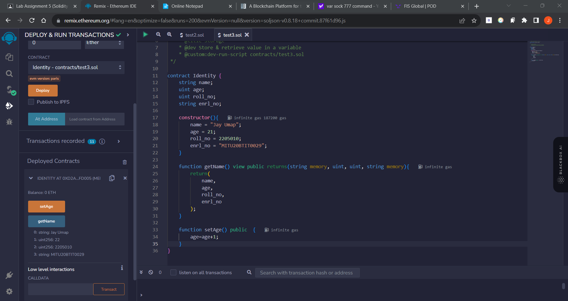Output:

